Nabbo - Product Loop Doc

Purpose
This document defines the core product loop for Nabbo.
The product loop is the repeatable behavior that must become natural for parents. If this loop works, Nabbo has a real product foundation. If this loop fails, no amount of features, branding, or interface polish will save the product.
The loop is simple:
A parent receives family logistics information. They Nabbo it. Nabbo extracts what matters. The parent verifies it. The system turns it into actions, owners, reminders, checklists, changes, and risks. The family uses Nabbo to execute the day.
The product should be built around this loop before anything else.

Core Behavior
The core behavior is:
Do not remember it. Nabbo it.
When a parent receives something that matters, they should not keep it in their head, leave it buried in WhatsApp, reread the same school email, or send another message to their spouse.
They should send it to Nabbo.
That behavior must feel faster, safer, and easier than remembering.
If the parent thinks, “I’ll just remember it,” the product loses.

The Product Loop
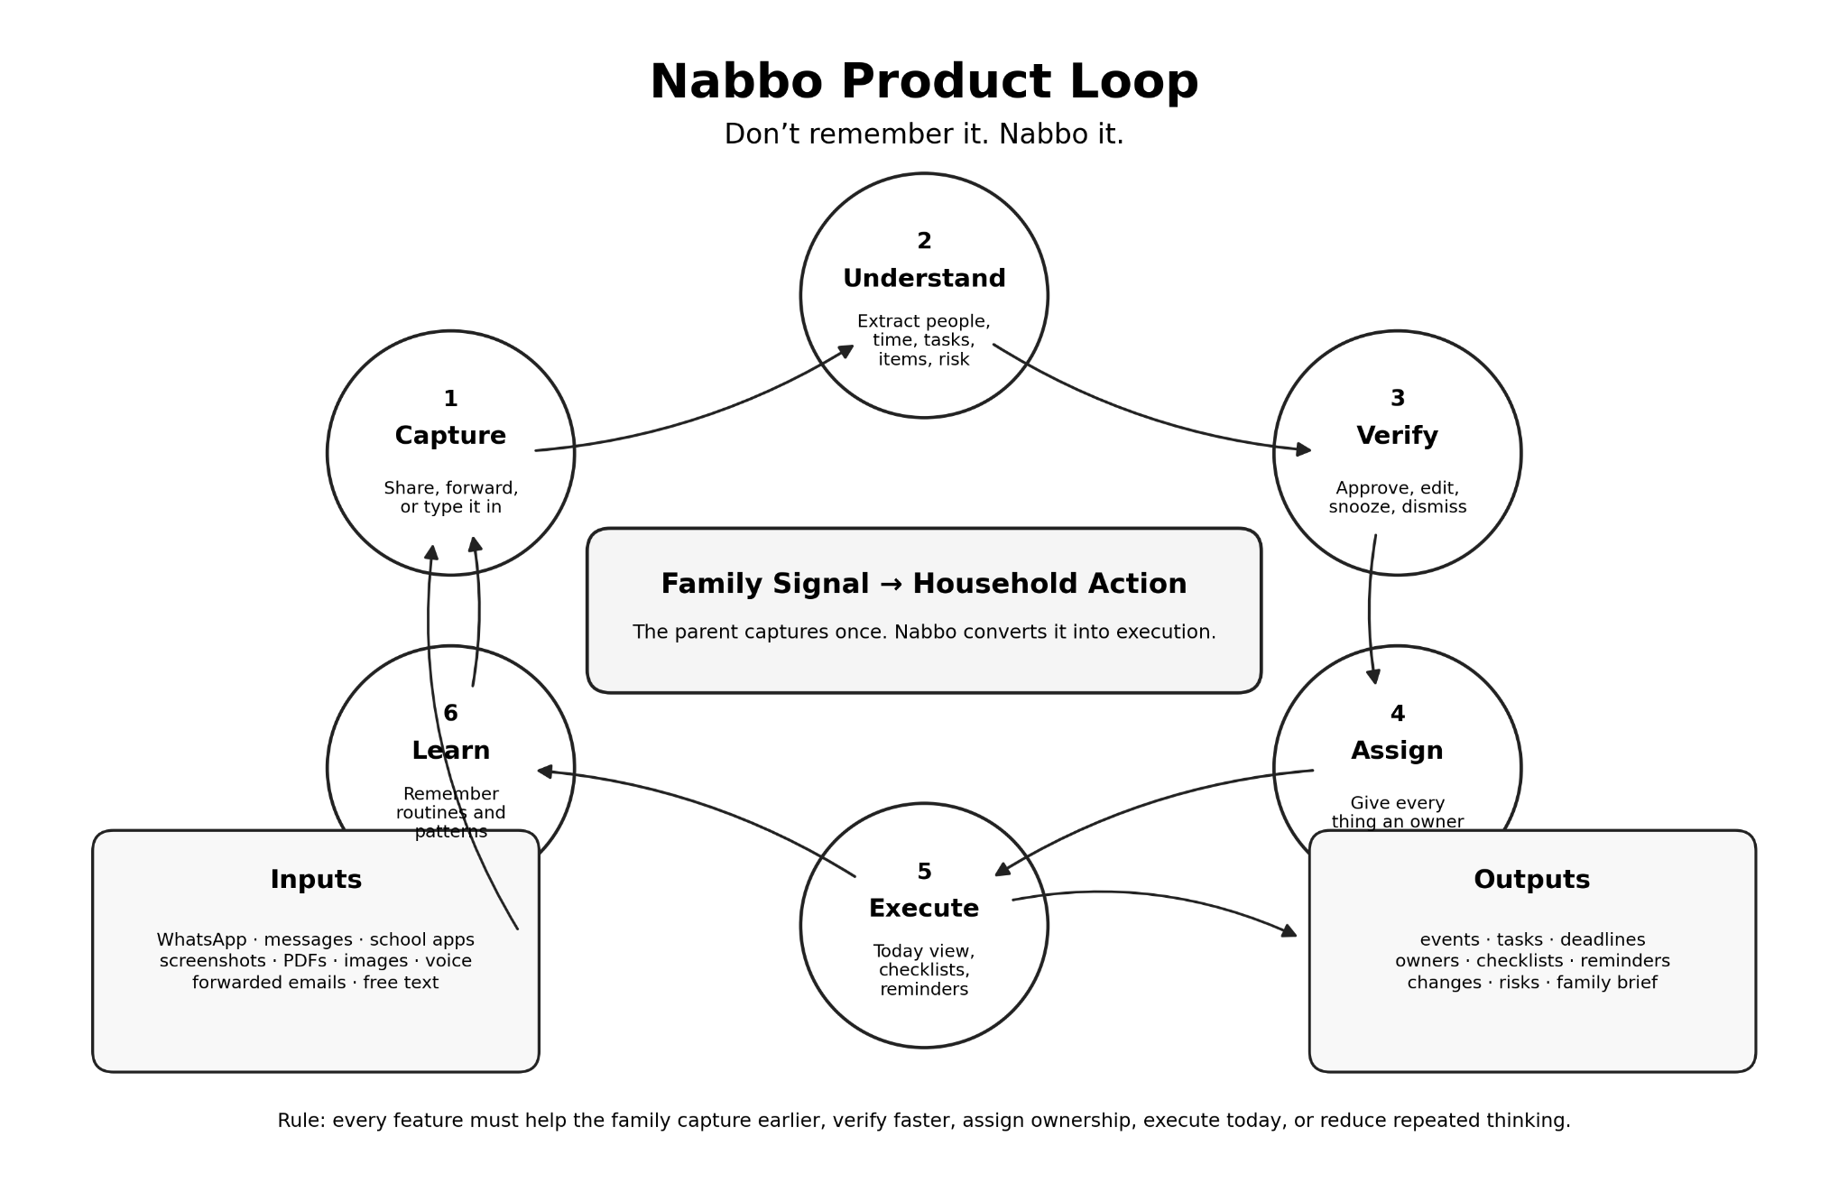
The Nabbo loop has six stages:
Capture, Understand, Verify, Assign, Execute, and Learn.
Each stage must reduce mental load. If a stage adds work without creating clear value, it is broken.

Stage 1: Capture
Capture starts when the parent receives a family signal.
A family signal can be a WhatsApp message, email, screenshot, PDF, image, voice note, school app message, copied text, or quick reminder from a child.
The parent sends the signal into Nabbo through one of three paths.
The first path is mobile share from iOS or Android. The parent shares content from WhatsApp, messages, school apps, screenshots, images, PDFs, text, or voice notes.
The second path is email forwarding. The parent forwards an email to the family’s Nabbo alias.
The third path is free text or voice inside the app. The parent types or speaks a quick note such as, “Adam needs €5 tomorrow,” or “Yara has basketball Friday at 6, bring blue jersey.”
Capture succeeds when sending something to Nabbo feels easier than remembering it.
Capture fails when the parent delays, forgets, or avoids using Nabbo because the input process feels too heavy.

Stage 2: Understand
After capture, Nabbo reads the input and extracts operational meaning.
The system should not only summarize the message. Summaries are not enough. Nabbo must understand what the message means for the household.
It should detect the affected family member, event, task, deadline, time, date, location, required items, form, payment, owner, urgency, change, and uncertainty.
For example, a school trip email is not just an event. It may contain a date, departure time, return time, location, payment deadline, permission form, packed lunch requirement, clothing instruction, and parent action.
Nabbo must break the message into usable household objects.
Understand succeeds when the system extracts the useful parts without forcing the parent to reread and process everything manually.
Understand fails when the system produces vague summaries, misses action items, guesses too much, or treats every message as a calendar event.

Stage 3: Verify
Nabbo should not push extracted information directly into the household plan without parent review.
Verification is the trust layer.
The parent sees a review card showing what Nabbo found. The original source remains visible. Extracted fields are clear. Uncertain fields are highlighted. Suggestions are separated from facts.
The parent can approve, edit, dismiss, snooze, assign, or mark the item as already handled.
This stage matters because AI will make mistakes. A wrong time, wrong date, wrong location, or missed deadline can break trust quickly.
Verify succeeds when the parent can check and approve an item quickly without doing the full mental work again.
Verify fails when the parent has to reread the whole message every time, correct too many fields, or loses confidence in Nabbo’s extraction.

Stage 4: Assign
Once verified, every action should either have an owner or be marked as unassigned.
Ownership is central to Nabbo.
A family task without an owner is not handled. It simply becomes invisible pressure. Nabbo should prevent that.
The owner can be a parent, spouse, child, caregiver, or “unassigned.” The system should highlight unassigned actions because they are risk points.
Examples include pickup ownership, payment ownership, form ownership, packing ownership, and follow-up ownership.
Assign succeeds when Nabbo makes responsibility clear before the task becomes a problem.
Assign fails when actions sit in the system without ownership, creating another passive list.

Stage 5: Execute
Execution is where Nabbo becomes useful in daily life.
The product must show what needs to happen now, today, tomorrow, and this week. It should not behave like a passive calendar.
The Today Command Center should answer:
What is next?
What needs attention now?
What must be packed?
What is due today?
What changed?
What has no owner?
What is at risk?
Execution includes reminders, preparation checklists, deadline alerts, change alerts, ownership gaps, and daily or weekly briefs.
Execute succeeds when the parent opens Nabbo during real pressure moments because it tells them what to do next.
Execute fails when Nabbo becomes another place to check, clean, or maintain.

Stage 6: Learn
Nabbo should become more useful over time.
The system should learn household patterns from repeated inputs and verified corrections.
It should learn family members, schools, clubs, activities, common locations, repeated routines, usual required items, and responsibility patterns.
For example, Nabbo should learn that swimming usually requires goggles and a towel, that football happens on Tuesday, that Yara’s school often sends forms as PDFs, and that one parent usually handles activity payments.
Learning should appear as useful suggestions, not intrusive automation.
Learn succeeds when Nabbo reduces repeated thinking.
Learn fails when the system makes assumptions too aggressively, feels creepy, or suggests irrelevant actions.

Loop Output
The loop should produce clear household outputs.
A captured message can become one or more of the following:
An event.
A task.
A deadline.
A required item.
A checklist.
A reminder.
A payment action.
A form action.
A location.
A change alert.
A risk alert.
An owner assignment.
A weekly brief item.
The product should not force every input into a calendar event. That would weaken the product.
Nabbo is not event-first. Nabbo is action-first.

Example Loop
A parent receives a WhatsApp message from a coach:
“Training moved to Friday 18:30 at the Sports Hall. Please bring water, blue jersey, and size 4 ball.”
The parent shares the message to Nabbo.
Nabbo extracts:
Child affected: Adam.
Event: Football training.
Date: Friday.
Time: 18:30.
Location: Sports Hall.
Required items: water, blue jersey, size 4 ball.
Change detected: training time changed.
Action needed: pack items before departure.
Owner: unassigned.
The parent verifies the card and approves it.
Nabbo updates the Today view, adds the required items to the checklist, flags the time change, and marks packing as unassigned.
Later, the parent sees:
“Football training at 18:30. Leave by 18:00. Bring water, blue jersey, and size 4 ball. Packing has no owner.”
That is the product loop working.

The Habit Test
The product must create a habit around capture.
The most important question is not whether users like the idea. Most parents will say they like it. That means little.
The real test is whether parents repeatedly send real family messages into Nabbo without being pushed.
The habit test is:
When a parent receives a school email, WhatsApp update, screenshot, form, or reminder, do they naturally think, “I should Nabbo this”?
If yes, the product has a chance.
If no, the product is just another productivity app.

Success Metrics
The product loop should be measured through behavior, not opinions.
The strongest signal is weekly captures per active household. If families are not sending inputs into Nabbo, the loop is dead.
A second signal is capture speed. Parents should be able to send something into Nabbo in seconds.
A third signal is verification trust. Parents should approve most extracted items without major correction.
A fourth signal is execution usage. Parents should open the Today Command Center during real planning or pressure moments, not only after receiving notifications.
A fifth signal is ownership clarity. Important actions should not remain unassigned.
A sixth signal is repeat use after novelty fades. If parents stop after a few days, the product has not become part of family operations.

Product Loop Risks
The first risk is capture friction. If Nabbo is slower than remembering, parents will not use it.
The second risk is weak extraction. If Nabbo summarizes but does not create useful actions, it adds little value.
The third risk is false confidence. If Nabbo hides uncertainty, it will make mistakes that damage trust.
The fourth risk is passive storage. If Nabbo becomes a nicer inbox or calendar, it fails to reduce mental load.
The fifth risk is missing ownership. If actions have no owner, the product does not solve household execution.
The sixth risk is over-notification. If Nabbo alerts too often, it becomes noise.
The seventh risk is over-learning. If Nabbo assumes too much too early, parents will feel the system is unreliable or intrusive.

Product Rules
Nabbo should make capture easier than memory.
Nabbo should convert information into action.
Nabbo should show uncertainty clearly.
Nabbo should keep the original source visible.
Nabbo should require verification before important actions enter the plan.
Nabbo should make ownership visible.
Nabbo should highlight changes and risks.
Nabbo should avoid becoming a chat app, calendar clone, or generic task manager.
Nabbo should reduce repeated thinking over time.

Final Loop Statement
Nabbo works when a parent can take any messy family signal, send it into the system, verify what matters, assign ownership, and trust that the household plan now reflects what needs to happen.
The loop is not about storing information.
The loop is about removing mental load and turning family noise into action.
Do not remember it.
Nabbo it.

